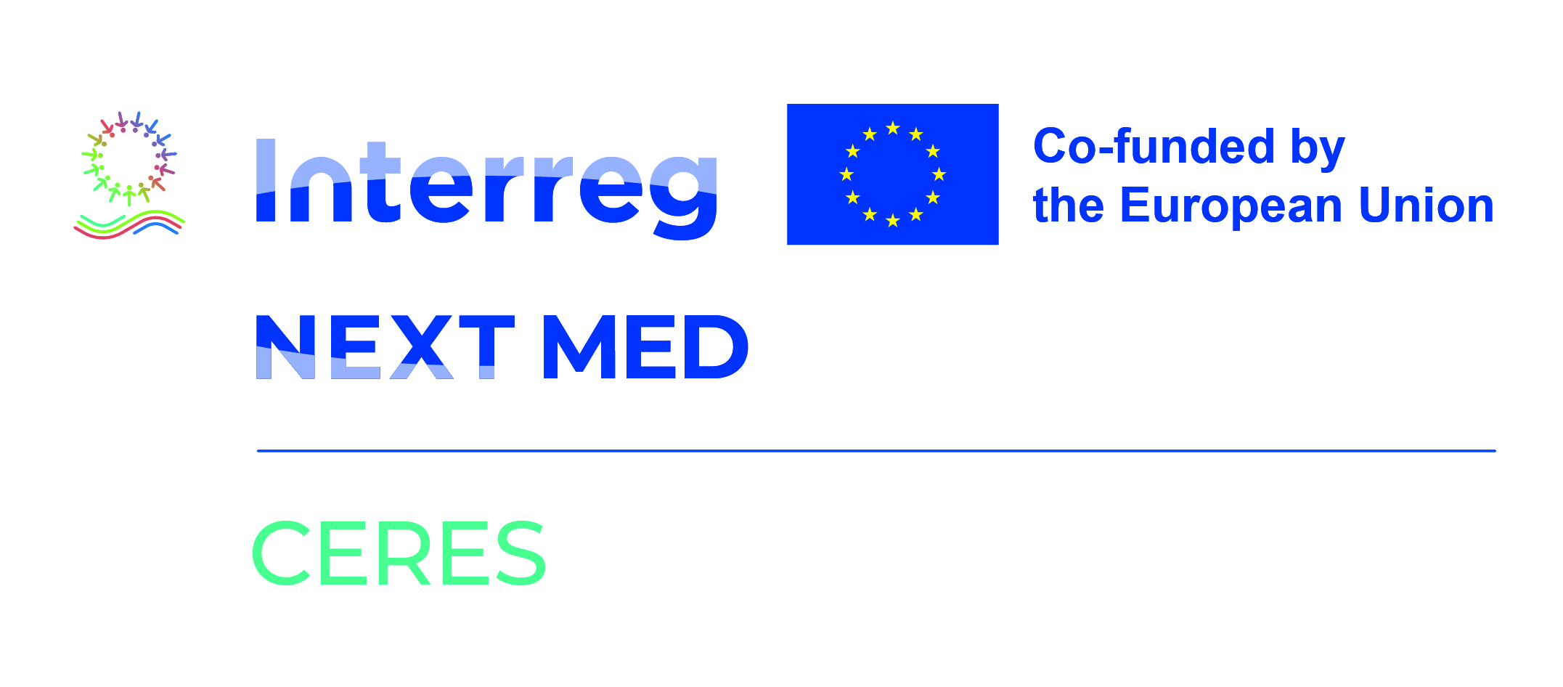
Request For Proposal (RFP)
LSES is looking for an Architectural Design of an Integrated Photovoltaic (PV) Solar Structure in Lebanon
The deadline to submit is February 27, 2026

The Lebanese Solar Energy Society (LSES) is lunching for its CERES project co-funded by the European Union under the Interreg NEXT MED Programme, a request for proposal for an Architectural Design of an Integrated Photovoltaic (PV) Solar Structure for a centralized solar street lighting system. The proposed design shall provide innovative and aesthetically pleasing architectural solutions that seamlessly integrate solar PV systems into a public space, while preserving and enhancing its social and urban value.
CERES – aims to enhancing sustainable growth and competitiveness of SMEs and job creation in SMEs, by promoting new business models, training programmes, and technology transfer mechanisms that accelerate the green and digital transition of Mediterranean economies.
The deadline to submit your proposal is February 27, 2026.
Interested candidates must contact the project team to obtain the Terms of References (ToR) via email info@lses-lb.org.
The subject line must mandatorily include the reference “ToR. Selection for an Architect for CERES/ LSES project”.

